Software Engineering

Spring 2019

Group name: Friends

Members: Randall Byrd, Riyazh Dholakia, Syed Kalam, Sujal Patel, Biprojoyti Paul

Date: 1/29/2019

Section 1:

Project name: Book a Cruise

Group Number: 1

Date of Submission: 2/1/2019

Section 2: Brief Resumes

Riyazh Dholakia: Georgia State University pursuing a bachelor’s in computer science. The languages I frequently use: Java, Swift, HTML, and CSS. The frequent software’s I use: XCode, Net Beans, and Visual Studio Code. I also interned as a Product Manager at Cox Automotive. I have worked on few iOS apps and websites also, that can be shown on my GitHub.

Randall Byrd: Georgia State University Undergraduate student in Computer Science. The languages that I am inclined in are Java, C, and Python. The software’s I use are: Visual Studio code, and Eclipse. I made a simple chat room (implemented in C) with Unix/Ubuntu Systems.

BiproJyoti Paul: I am a student at Georgia State University. My major is Computer Science. I like to make some front-end application on my free time. For this, I use HTML, CSS, Javascript. The software that I use: Visual Studio Code, Eclipse, Visual Studio, Xcode. I just got a remote internship at Good Mood. Some of my front-end applications can be found on my GitHub- Bipro 723.

Syed Kalam: My name is Syed, and I’m a Junior at Georgia State University. I'm pursuing my bachelor’s degree in Computer Science.  In the course of my classes I've been familiarized with many languages. I prefer using Java for coding and SQL database for the back-end data. I have also learned how to operate Visual Studio, and currently I'm also learning Android Studio to make android apps. Along with my studies, I work part time at a company, Aasdel Corporation as a sales manager. I'm responsible for managing the inventories in their system and satisfying the customers with the product quality.

Sujal Patel:  I am a student at Georgia State University pursuing a bachelor’s in computer science. The languages I have experience with, Java, C++ and HTML. The software I use is Visual Studio, Android Studio, Eclipse.

Section 3: Scheduling and planning

**Work Breakdown Structure**

|  |  |  |  |  |  |  |
| --- | --- | --- | --- | --- | --- | --- |
| **Assignee Name** | **Email** | **Task** | **Duration (hours)** | **Dependency** | **Due date** | **Note** |
| Riyazh Dholakia (**coordinator**) | rdholakia1@student.gsu.edu | Creating the GitHub repository as described in the assignment, and make assigned table to assign tasks to everyone, Write personal brief Resume, submit assignment | 3 hours | GitHub, Everyone to finish task so I can submit it | 01/27/19 | Please send everybody GitHub repo invite. |
| Sujal Patel | spatel287@student.gsu.edu | Create GitHub Project tab (To Do, In Progress, and Done),  Create readme, Commit pdf to GitHub, Write personal brief Resume | 3 hours | GitHub, assigned table | 01/31/19 | Make sure GitHub project board tasks are complete. |
| Randall Byrd | rbyrd11@student.gsu.edu | Do the System Requirements task, and put the final pdf together for submission, Write personal brief Resume | 3 hours | Assigned tasks, wait until everyone finishes their task to put together project | 01/31/19 | Remind everyone to do a final push to GitHub docs. |
| Syed Kalam | skalam1@student.gsu.edu | Do the teamwork basics and answer the questions, Write personal brief Resume | 3 hours | Assigned tasks, reading book | 01/31/19 |  |
| Biprojoyti Paul | bpaul5@student.gsu.edu | Do the problem statement and answer the questions, Write personal brief Resume | 3 hours | Assigned tasks | 01/31/19 | . |

Section 4: Problem Statement

Section 5: System Requirements

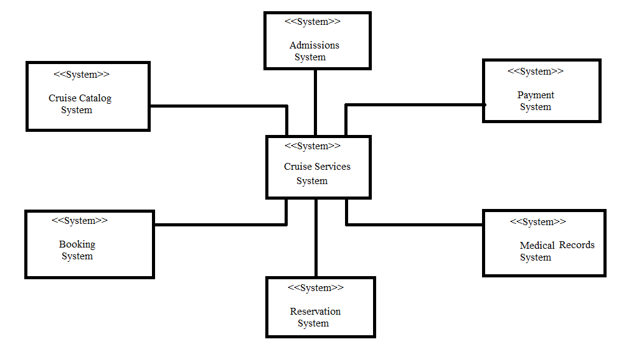

-In this context model the Cruise services system is the main system connected to various systems in its environment: The payment system generates payments made out from the clients to the main system. The medical records system keeps track of customers medical records, for example if a cruise is to go out of the country then appropriate shots are needed to be on file. The admissions system keeps track of customers accounts, and reviews new customers. The cruise catalog system is a list of all the available cruises in the system, and the booking system allows clients to book their desired cruise.